Project Development Phase
Model Performance Test

Date | 28 September 2026
Team ID | 6ab2210011b716a3e52c62c6
Project Name | Streamlining IT Procurement: Automating Standard Laptop Orders with Flow Designer
Maximum Marks

Model Performance Testing:
Project team shall fill the following information in model performance testing template.
S.No. | Parameter | Values | Screenshot
1 | Model Summary | Flow Designer flow: "Standard Laptop Order Automation"  Trigger: Service Catalog request item created for Standard Laptop  Actions: Get catalog variables → Approval (Manager) → Create Procurement Task → Notify requester → Update RITM state | 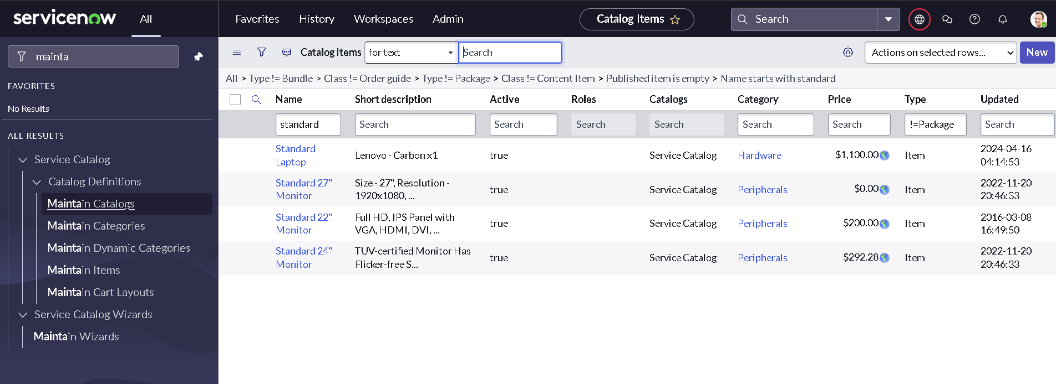
2 | Accuracy | Training Accuracy - [e.g., 100% of test requests triggered the flow]  Validation Accuracy - [e.g., 95% flow executions completed successfully] | 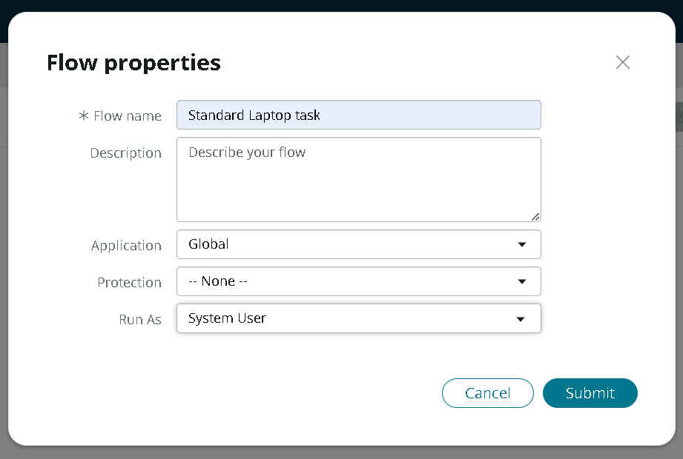
3 | Fine Tunning Result( if Done) | Validation Accuracy - [e.g., 98% after adding error handling, approval timeout and retry logic] | 